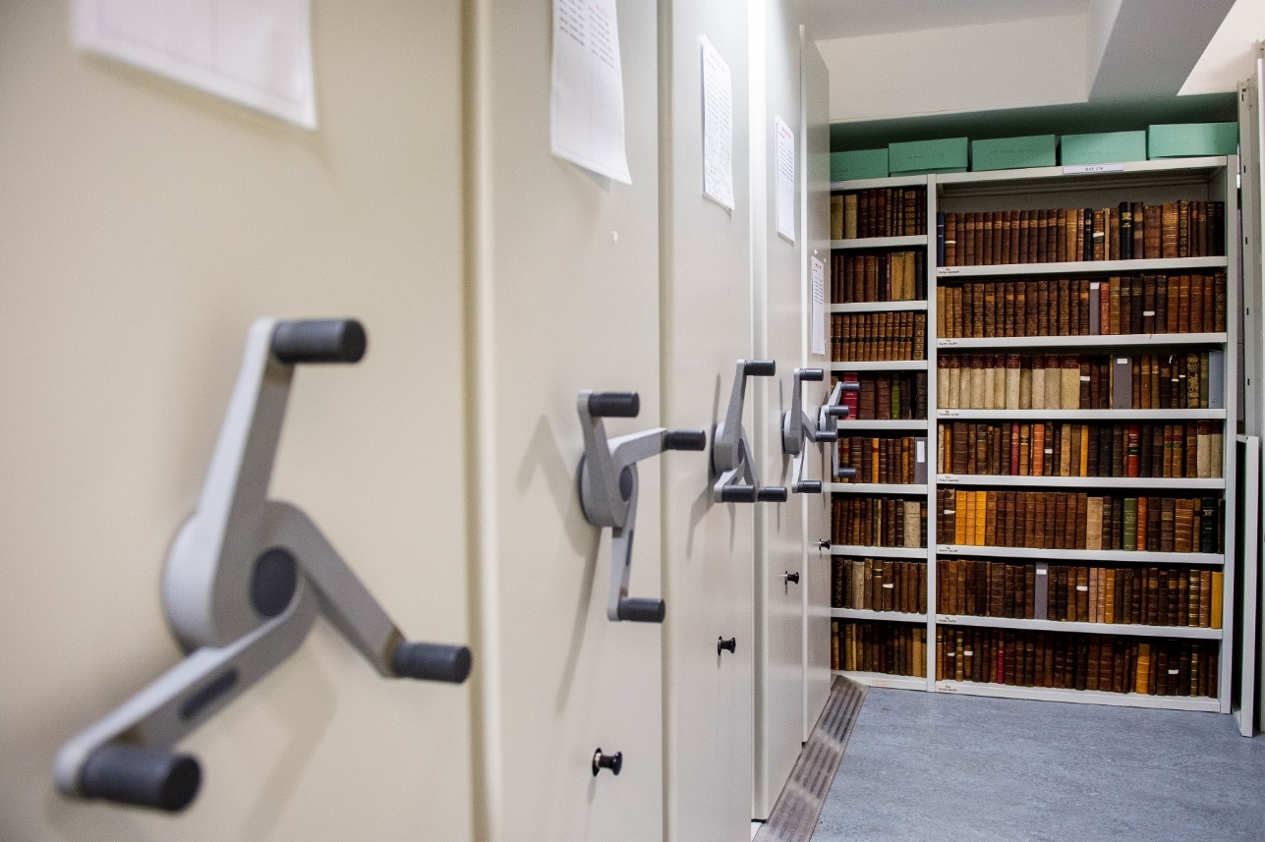

Records Management- Frequently Asked Questions

Contents

1. Records Management 3

1.1 What are records? 3

1.2 What about digital records? 3

1.3 What formats can records be in? 3

1.4 What is records management? 3

1.5 What does records management involve? 3

1.6 Why is records management important? 3

1.7 Are you responsible for Data Protection? 4

1.8 Who is responsible for the records created by my team? 4

1.9 How can the Records Management Team help me? 4

2. Retention 5

2.1 How long should I keep my records for? 5

2.2 So how do I know what to do with my records? 5

2.3 Where can I find the retention schedule? 5

2.4 How is the retention schedule structured? 5

2.5 Which part of the retention schedule do I need to use? 6

2.6 How do I use the retention schedules? 6

2.7 Can I keep a record for longer than the retention period? 7

2.8 How long should I keep coursework and exam scripts for? 7

2.9 What should I do if I think a specific part of the retention schedule needs updating? 7

3. Storage 8

3.1 Where should I keep my records? 8

3.2 What if I don’t have space for my records? 8

3.3 Can the Records Management Team store my records? 8

3.4 My department has lost some paper records. Can you help me find them? 9

3.5 I am aware of an abandoned room that contains records. What should I do? 9

3.6 How should I store my paper records? 9

3.7 What stationery should I use with my paper records? 10

4. Disposal 11

4.1 How should I get rid of my records? 11

4.2 What is confidential waste? 11

4.3 How can I dispose of confidential waste? 11

4.4 Do I have to follow certain procedures when I destroy records? 12

4.5 Are there any records I can get rid of on a regular basis? 12

5. Archive 13

5.1 Should I send my records to the University Archives? 13

5.2 What records should I send to the University Archives? 13

5.3 Should I transfer records I am still using to the University Archives? 14

6. Training and Guidance 15

6.1 Can I get some training on records management? 15

6.2 I’m leaving my office soon. Can I have some help with sorting my records? 15

6.3 A member of my team is leaving. What should we do with their records? 15

6.4 Are there any additional guidance documents? 15

6.5 How can I contact the Records Management team? 16



# 1. Records Management

## 1.1 What are records?

Records are the information created, received and maintained as evidence and as an asset by an organization or person, in pursuit of legal obligations or in the transaction of business.

## 1.2 What about digital records?

Records are not limited to paper but include digital records. The Records Management Team has been prioritising the legacy paper records at UWTSD and therefore this guidance is primarily oriented towards paper records, but it does also apply to digital records. It is worth remembering important digital records could also be stored on old computers, USBs, floppy discs etc.

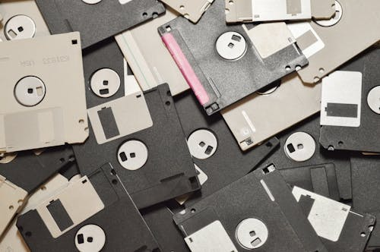

## 1.3 What formats can records be in?

Records can come in any format; what is important is the information they contain. Records could be emails, correspondence, minutes, application forms, coursework etc.

## 1.4 What is records management?

Records Management aims to ensure the efficient and systematic control of records from their creation and use to their disposal.

1.5 What does records management involve?

Records management involves many aspects including (but not limited to):

* Retention – how long records should be kept for.
* Storage – where and how records should be stored.
* Disposal – how records should be disposed of once they no longer need to be retained (this includes transferring them to an archive).
* Training and guidance – to ensure best practice is promoted.

## 1.6 Why is records management important?

Records management is important to ensure that:

* Staff can find records more efficiently, meaning they are able to save time and make informed decisions.
* Staff resources are not being wasted on storing records which do not need to be retained.
* Records are protected from hazards and unauthorised access.
* Information is retained for the correct period of time.
* Records are disposed of appropriately.
* The University complies with legal obligations and standards (including legislation on Data Protection and Freedom of Information).
* Reputational damage is avoided.
* The corporate memory of the University is preserved.

## 1.7 Are you responsible for Data Protection?

While good records management is vital to ensuring Data Protection legislation is followed, Data Protection is not the responsibility of the Records Management Team. Any questions or issues relating to Data Protection should be directed to the Data Protection Officer ([foi@uwtsd.ac.uk](mailto:foi@uwtsd.ac.uk)).

## 1.8 Who is responsible for the records created by my team?

Records are typically the responsibility of the departments, teams and individuals who create them. A different department, team or individual could become responsible for them; for example, if they are transferred to a different department or to an archive. The Records Management Team is not responsible for the records created by your team.

## 1.9 How can the Records Management Team help me?

The Records Management team can provide recordkeeping advice, guidance and support to members of staff across the University. This can range from answering enquiries to providing training or being involved in projects to helping teams assess their records. For further details please contact us at [records@uwtsd.ac.uk](mailto:records@uwtsd.ac.uk).

# 2. Retention

## 2.1 How long should I keep my records for?

How long a record needs to be kept will depend on the type of record it is. Some records can be disposed of once they have fulfilled their functions whereas other records will need to be retained permanently.

## 2.2 So how do I know what to do with my records?

The retention schedule for the University will tell you how long records should be retained for and what to do with them at the end of this retention period. The schedule applies to all university records regardless of their format or the department they come from.

## 2.3 Where can I find the retention schedule?

The retention schedule can be found on the Records Management [intranet page](https://intranet.uwtsd.ac.uk/departments/library-and-learning-resources/llr-strategy-and-policies/records-management). This can be found under Library and Learning Resources > Our strategy and policies > Records Management. If you have any difficulty finding it, then please email [records@uwtsd.ac.uk](mailto:records@uwtsd.ac.uk).

2.4 How is the retention schedule structured?

The retention schedule is divided into nine subsections:   
1. Student Administration and Support   
2. Teaching   
3. Research   
4. Corporate Governance   
5. Human Resources   
6. Finance   
7. Estates and Facilities   
8. External and Public Relations   
9. Information Services   
  
It is worth noting that the records are not organised by department but by business function and activity. For example, any financial records created by any department (such as invoices) are listed within the ‘Finance’ subsection. This means that most departments will hold records belonging to various subsections of the retention schedule.

## 2.5 Which part of the retention schedule do I need to use?

Which subsection of the schedule you will need to use will depend on the record. In some incidences it will be apparent where the record will be found (for example, invoices will be under Finance). However, in other cases you may be unsure which is the relevant subsection. On the Records Management [intranet page](https://intranet.uwtsd.ac.uk/departments/library-and-learning-resources/llr-strategy-and-policies/records-management) there is a Contents section for the schedule. This can be used to find the relevant subsection. If you are struggling to find a record using the retention schedule, please contact us at [records@uwtsd.ac.uk](mailto:records@uwtsd.ac.uk).

Example of our Retention Schedule

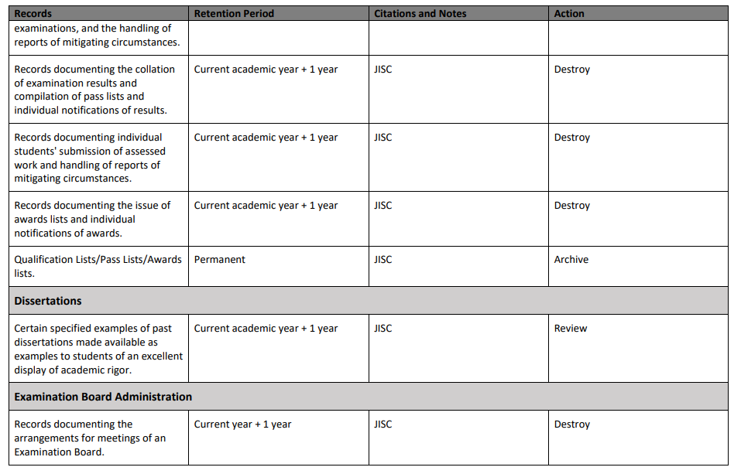

2.6 How do I use the retention schedules?

The schedules are divided into nine subsections as noted above. Within each subsection (e.g. Student Administration and Support), the retention schedule is arranged by business activity (e.g. student admission). Under each activity, you will find a list of the type of records it produces, the length of time (retention period) for which these records should be kept, and the action to be undertaken at the end of the retention period. Notes about any relevant legislation or guidance are also provided.  
  
You need to find the relevant record in the schedule, ensure it is retained for the retention period and that it is dealt with appropriately after this.  
  
There are three possible actions to be undertaken at the end of the retention period:  
  
**Archive** - Transfer records to the University Archives. Before sending any material to the University Archives, please contact the Records Management team for advice at [records@uwtsd.ac.uk.](mailto:records@uwtsd.ac.uk) Further details about this can be found in section 5 of this document.   
**Destroy** - Some records can be placed in standard recycling bins. Any records containing personal data must be destroyed confidentially. Legally, we need to be able to prove how and when records were destroyed. Further details about this can be found in section 4 of this document.  
**Review** - Consult with the Records Management team to determine whether the records should be retained for longer, transferred to an archive or destroyed.

If you have any questions about implementing the retention guidelines or if you are unable to find a particular record, please contact us at [records@uwtsd.ac.uk](mailto:records@uwtsd.ac.uk) for advice.

2.7 Can I keep a record for longer than the retention period?

If you are concerned about the ramifications of destroying a record at the end of the retention period (particularly if you feel it has operational, evidential or legal value) then please contact the Records Management team at [records@uwtsd.ac.uk](mailto:records@uwtsd.ac.uk). Please note that as the retention schedule is in many places based on the law, you may not be able to keep the record for longer than the retention period. However, there are circumstances where this may be possible (for example, if another set of records has been prematurely destroyed – other records could be retained for longer to mitigate the risks associated with this).

## 2.8 How long should I keep coursework and exam scripts for?

Exam scripts and coursework are listed as “Submitted/completed assessments (formative and summative assessments” in the Retention Schedule and come under the Teaching subsection. They need to be retained until the “End of student relationship + 2 years” at which point they should be destroyed.

It is worth noting that “Final versions of taught module assessments” needs to be retained for the life of the module and then may need to be transferred to an archive. This would be a single blank copy of each assessment as opposed to completed assessments.

## 2.9 What should I do if I think a specific part of the retention schedule needs updating?

Please contact the Records Management Team at [records@uwtsd.ac.uk](mailto:records@uwtsd.ac.uk) if you think a part of the retention schedule needs amending, or if you think a record that is not on the retention schedule may need to be added. Please remember that retention periods and outcomes will not necessarily be altered as they apply to the whole University and are often based on the law, best practice guidelines or internal decisions. Likewise, not every record needs to be on the schedule.



# 3. Storage

## 3.1 Where should I keep my records?

Paper records could be kept in several locations such as offices, specific storage rooms or the University Archives. It is important that all storage locations are secure, particularly if they contain sensitive or personal information. Records should not be kept in staff members’ houses, other workplaces, cars etc. Records only need to be transferred to the archives if they need to be retained permanently.

Digital records should be kept on university devices, SharePoint/Microsoft Teams or on OneDrive. Digital records should not be stored on home devices or on other independent storage systems without discussing this with IT. We understand specific departments may already use specific databases or storage systems in line with operational requirements; this is fine if IT is aware of the situation. Only personal records should be saved directly to university devices or OneDrive as it is important that records needed by other team members can be accessed if an individual staff member is absent.



3.2 What if I don’t have space for my records?

The first step is to determine whether you need to keep all your paper records. If you look at the University retention schedule, you may find that you can get rid of some records. If these are your individual or team records, it may also be worth contacting your wider department to see if there is available storage space elsewhere.

After this, if you still do not have space for your records, please contact Estates to determine if you can be allocated additional space ([operations@uwtsd.ac.uk](mailto:operations@uwtsd.ac.uk)). It may also be possible to arrange off-site record storage with an external provider for an ongoing fee; please contact the Records Management Team to discuss this ([records@uwtsd.ac.uk](mailto:records@uwtsd.ac.uk)).

3.3 Can the Records Management Team store my records?

The Records Management Team cannot store departmental records due to a lack of capacity and storage space. We do currently store and manage paper legacy records, but we are unable to accept new or current records. We can provide advice and guidance in terms of your own departmental records storage.

## 3.4 My department has lost some paper records. Can you help me find them?

We may potentially be able to help you find records that your department has lost, particularly if they were abandoned paper legacy records. Please note that we may not always be able to help you and that we are not responsible if the lost records cannot be located or accessed. It is worth noting that the loss of personal data might be considered a personal data breach which would need to be reported to the University’s Data Protection Officer ([foi@uwtsd.ac.uk](mailto:foi@uwtsd.ac.uk)).

## 3.5 I am aware of an abandoned room that contains records. What should I do?

If a room is being used to store records and it is not being managed by an existing department or team, then please contact the Records Management Team ([records@uwtsd.ac.uk](mailto:records@uwtsd.ac.uk)). We may already know about the room. If this is not the case, we will either manage the records ourselves as paper legacy records or contact the relevant department to ensure they manage them.

3.6 How should I store my paper records?

You should store your records in a location that is:

* Free from mould which is a risk to records and human health.
* Free from pests including insects (please email [records@uwtsd.ac.uk](mailto:records@uwtsd.ac.uk) if you are concerned insects are eating your records).
* Dry and does not have a history of leaks (consider where the nearest water sources are).
* Easily accessible for staff members.
* Safe for staff members to access.
* Locked and only accessible to authorised staff.
* Organised and arranged in a logical manner.

It is important that you do not eat and drink inside record stores as this could directly damage the records and attract pests. You should regularly check your records store to minimise any damage arising from mould, pests or leaks.

3.7 What stationery should I use with my paper records?

If you need to keep your records for a long period of time it may be best to avoid using plastic wallets, post-it notes, sellotape, rubber bands and metal fastenings (i.e. paper clips, staples and bulldog clips). Cardboard folders/boxes, plastic/brass paperclips and plastic treasury tags are all preferable.

Putting your records on shelves offers additional protection against damp and leaks. It is also a more efficient use of space and more convenient for staff members.

If you require shelves, cabinets, drawers or filing cabinets it may be worth asking Estates if they have any spare ([operations@uwtsd.ac.uk](mailto:operations@uwtsd.ac.uk)).

4. Disposal

4.1 How should I get rid of my records?

Some records can be placed in standard paper recycling bins. Any records containing personal or sensitive data must be destroyed confidentially.

## 4.2 What is confidential waste?

Records need to be disposed of as confidential waste if they contain:

1. Personal information – information on identifiable living individuals such as student or staff personnel records.
2. Sensitive business information – commercially sensitive information (which may breach commercial confidentiality) such as unpublished research material, contracts, tenders, insurance records etc.

This would not apply if these records were already part of the public domain (e.g. a prospectus). It is important to note that the format of a record has no bearing on if it is confidential, for example emails can contain confidential information. If you have any questions about whether material is confidential, please contact the Records Management Team ([records@uwtsd.ac.uk](mailto:records@uwtsd.ac.uk)). If in doubt it is better to dispose of the material as confidential waste.

4.3 How can I dispose of confidential waste?

Confidential waste cannot be placed in normal waste or recycling bins across the University. It is important that it is disposed of properly to ensure we comply with Data Protection legislation.

For the disposal of small amounts of confidential waste, you can cross-shred the material and place the shredded paper in the paper recycling bins.

For larger amounts of confidential waste, specific confidential waste bins and bags can be requested by raising a [Maintenance Request](https://quantarc.uwtsd.ac.uk/helpdesk/new-request/common-problem) on Quantarc via the Hwb.

When using a confidential waste bin/bag please note that only paper should be placed in the bin. You must not place any folders, ring binders, lever arch files, box files, poly pockets, discs, USBs etc. into the confidential waste bin.

Once the confidential waste bin/bag is full please submit another Quantarc request to arrange collection. Please ensure that the confidential waste bin/bag is kept in a secure and locked area before it is collected. Once the waste has been collected it will be destroyed by an external company.

Discs, UBSs floppy discs etc. containing potentially confidential information should not be placed in general waste or recycling and will need to be collected separately from the paper confidential waste.

If you have any general questions about confidential waste, please email [waste@uwtsd.ac.uk](mailto:waste@uwtsd.ac.uk).

4.4 Do I have to follow certain procedures when I destroy records?

Yes! Legally, we need to be able to prove how and when records were destroyed for audit purposes. The Records Management team designed a Records Disposal Form to record this information. The form records a description of the records, the covering dates, the reason for destruction according to the retention schedule (if applicable), who authorised the destruction and when the records were collected for destruction. This form can be found on the Records Management [intranet page](https://intranet.uwtsd.ac.uk/departments/library-and-learning-resources/llr-strategy-and-policies/records-management) and applies to digital as well as paper records.

4.5 Are there any records I can get rid of on a regular basis?

The records listed below have no significant operational, informational or evidential value and can be destroyed as soon as they have served their primary purpose. This guidance applies to both paper and electronic records.

* Meeting announcements/notices and notifications of acceptance/apologies
* Requests for stock information (e.g. maps, travel directions, brochures)
* Transmission documents which provide no additional information (e.g. compliment slips)
* Superseded address/distribution lists
* Duplicate documents (e.g. unaltered draft documents, cc/FYI copies)
* Documents printed or photocopied for own use
* Personal diaries, personal notes and address books
* Personal copies of records (unless there is a reason to believe the original copies may be missing)
* Publications received from external organisations (e.g. trade magazines, vendor catalogues, flyers, newsletters)

5. Archive

5.1 Should I send my records to the University Archives?

If there is sufficient storage space, the University Archives will accept certain records that need to be retained permanently. Records that require long-term but not permanent retention should not be stored at the University Archives. There is a University Archive in Lampeter (the Roderic Bowen Library and Archive) and the Swansea (the Swansea Institutional Archive). Both archives can be contacted at [specialcollections@uwtsd.ac.uk](mailto:specialcollections@uwtsd.ac.uk) and should be consulted before sending them any material. The Special Collections and Archives Team may require you to complete a form regarding the deposit/transfer of material.

## 5.2 What records should I send to the University Archives?

The University Archives hold the institutional records of all constituent members of UWTSD. These are held for legal and historical reasons and to preserve the University's corporate memory. The following records are some examples of what would be welcomed by the University Archives:

* Annual accounts
* Building plans for all campuses and buildings
* Committee records, e.g. agenda, minutes, supporting papers
* Graduation ceremony brochures
* In-house publications, e.g. magazines, marketing materials, prospectuses etc.
* Photographs
* Press releases
* Student newsletters/magazines

This is not an exhaustive list and there will be other records which have archival value. If you have records you think may potentially belong in an archive, please contact the Special Collections and Archives Team for advice.

The University Archives only need one copy of any of these records, so please check with the Special Collections & Archives Team before sending any material. You can email [SpecialCollections@uwtsd.ac.uk](mailto:SpecialCollections@uwtsd.ac.uk) for information and guidance.

## 5.3 Should I transfer records I am still using to the University Archives?

Some teams and departments may continue to hold records which need to be permanently retained while they still have a use for them and only transfer them to the archive once they are no longer being actively used. If records are transferred to an archive, it may still be possible to access them (under supervision) if the business need arises. Original records could also be transferred to the archive, and the team/department could retain copies of the records. Please contact the Records Management Team for further advice ([records@uwtsd.ac.uk](mailto:records@uwtsd.ac.uk)).



# 6. Training and Guidance

## 6.1 Can I get some training on records management?

Yes, the Records Management Team can deliver a general training session on record management. This training is designed for groups and to give a brief introduction to managing records relevant to all staff members regardless of grade or department. Training sessions can be run online or in person depending on staff availability and resources. It may be possible to tailor the training to the specific needs of a certain team. The training typically lasts between an hour and 90 minutes – this can be discussed when booking the training ([records@uwtsd.ac.uk](mailto:records@uwtsd.ac.uk)).

6.2 I’m leaving my office soon. Can I have some help with sorting my records?

The Records Management team will provide advice and guidance about what you should do with your records, but you will need to sort and dispose of the records yourself. Please give us as much notice as possible so we can offer appropriate assistance. You should not leave records behind in your old office without clear instructions regarding their disposal or re-location. A guidance document about office moves can be found on the Records Management [intranet page](https://intranet.uwtsd.ac.uk/departments/library-and-learning-resources/llr-strategy-and-policies/records-management).

6.3 A member of my team is leaving. What should we do with their records?

It is important that their records are processed in line with the retention schedule before they leave. Specific guidance on staff leavers can be found on the Records Management [intranet page](https://intranet.uwtsd.ac.uk/departments/library-and-learning-resources/llr-strategy-and-policies/records-management).

6.4 Are there any additional guidance documents?

Yes, on the Records Management [intranet page](https://intranet.uwtsd.ac.uk/departments/library-and-learning-resources/llr-strategy-and-policies/records-management) you can find additional guidance documents on how to use the retention schedule, file naming and email management. If you have any suggestions for additional guidance documents, please tell us.

6.5 How can I contact the Records Management team?

You can email the Records Management team at [records@uwtsd.ac.uk](mailto:records@uwtsd.ac.uk). Please don’t be afraid to ask for help. We are aware that records management can seem overwhelming, but the Records Management Team is here to provide advice and support.